Metrics & Monitoring Environment validation

Intro: The Metrics & Monitoring team is responsible for the administration of a global monitoring infrastructure. By utilizing CSG StatHub, Microsoft System Center Operations Manager 2012, Zabbix and BMC Proactive Net Performance Management Suite, we can provide all levels of monitoring for over 3600 Windows and UNIX/Linux servers.
From 3rd party vendor to custom solutions, the Metrics & Monitoring team is positioned to provide the solution to the problem you are trying to solve.
M&M Validation Tasks are performed as a response for Patching or Deploying activities performed by various teams. We need to validate our environment before and after any such kind of activity takes place. Below mentioned are the certain steps to follow while validating our environment.
Basic Steps:
- Review Validations on the Stats page (see URL above)
- Determine if the Validation requires a bridge (usually a BigIP bridge will be send to the M&M distro).
- If there is no bridge you may perform the Validation any time after the CRQ end time.
- If there is a bridge you should perform a precheck prior to the work starting and a post check after the work has been complete.
- Go into remedy ticket and assign yourself (if it hasn't happened already)
- Choose "Create Validation Task" to track the validation steps.
- Once the Validation is complete open the M&M task in remedy and mark the task as complete and choose successful or unsuccessful and choose to save.
Confluence Validation Page: https://confluence.csgicorp.com/pages/viewpage.action?pageId=769297250
SCOM:
Step 1: Launch SCOM EMPROD
Step 2: Open Active Alerts Pane
Make sure data is return
Check alerts and make sure they are near current (=< 5 minutes)
Step 3: Launch SCOM EMDEV
Step 4: Open Active Alerts Pane
Make sure data is return
Check alerts and make sure they are near current (=< 20 to 30 minutes)

Proactive Net:
Step 1: Login Proactive Net from Citrix environment
Step 2: Make sure the application is available.

StatHub: PROD
StatHub should be validated by CVPs.
Check here for status. http://cvp.csgicorp.com:8080/view/Stathub-prod/job/CVP-PROD-StatHub/
StatHub Portal:
Check whether the data is reflecting in the below Stathub links
http://stathub.csgedirect.com/StatHubPortal_PROD
http://comcast-stathub.csgedirect.com/StatHubPortal_PROD
http://twc-stathub.csgedirect.com/StatHubPortal_PROD
http://eastlink-stathub.csgedirect.com/StatHubPortal_PROD
http://teco-stathub.csgedirect.com/StatHubPortal_PROD
StatHub: PRE
StatHub should be validated by CVPs.
Check here for status. http://cvp.csgicorp.com:8080/view/Stathub-prod/job/CVP-PRE-StatHub/
StatHub Portal:
Check whether the data is reflecting in the below Stathub links
http://stathub-pre.csgedirect.com/StatHubPortal_PRE
http://comcast-stathub-pre.csgedirect.com/StatHubPortal_PRE
http://twc-stathub-pre.csgedirect.com/StatHubPortal_PRE
http://eastlink-stathub-pre.csgedirect.com/StatHubPortal_PRE

StatHub UNIT CVP: http://cvp-nonprod.csgicorp.com:8080/job/CVP-UNIT-StatHub/
StatHub AIQA CVP: http://cvp-nonprod.csgicorp.com:8080/job/CVP-AIQA-StatHub/
StatHub QAINT CVP : http://cvp-nonprod.csgicorp.com:8080/job/CVP-QAINT-StatHub/

Zabbix:
Step 1: Log into Zabbix. If everything loads on the dashboard you are good.
Zabbix link: http://omaprdxevms02.csgiprod.com/zabbix/index.php
Go to latest data and check the recent data time for any host (time is in CT)
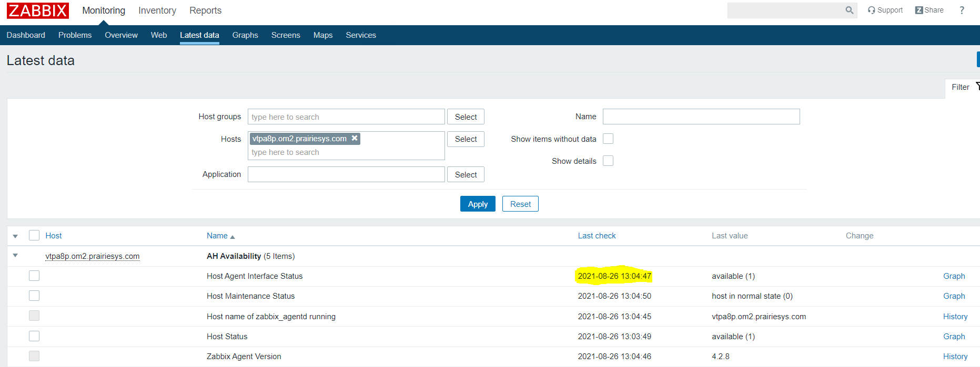

Rabbit MQ:
Step 1: Navigate to the rabbit queue website. We have two serves that are load balanced through BigIP. Check the environments page to confirm which servers to use. Pre and Prod servers listed below.
http://accprdisrsp0001.csgiprod.com:15672/
http://omaprodstha06.prodcsg.com:15672/#/
Step 2: If one of the sites doesn't work check the other one. If one is down and the other is up there likely an issue or one of the servers is rebooting.
**Login with guest account**
Step 3: Overview
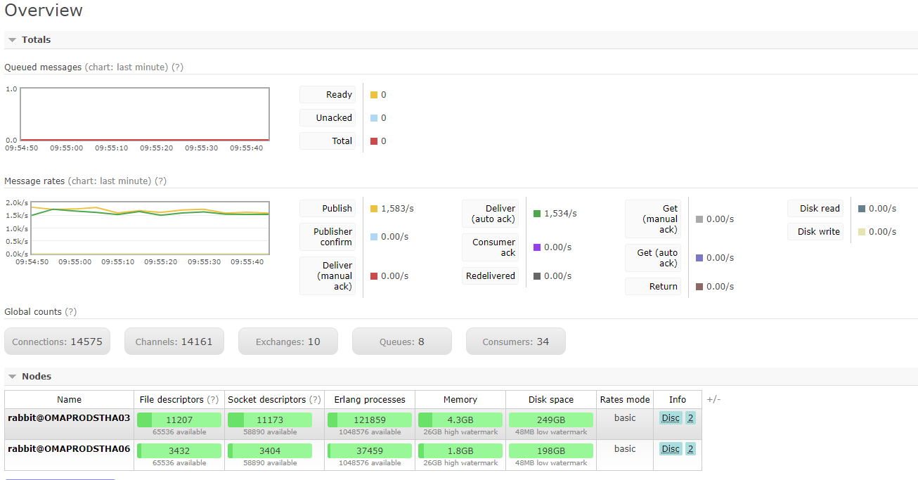

Step 4: Queues
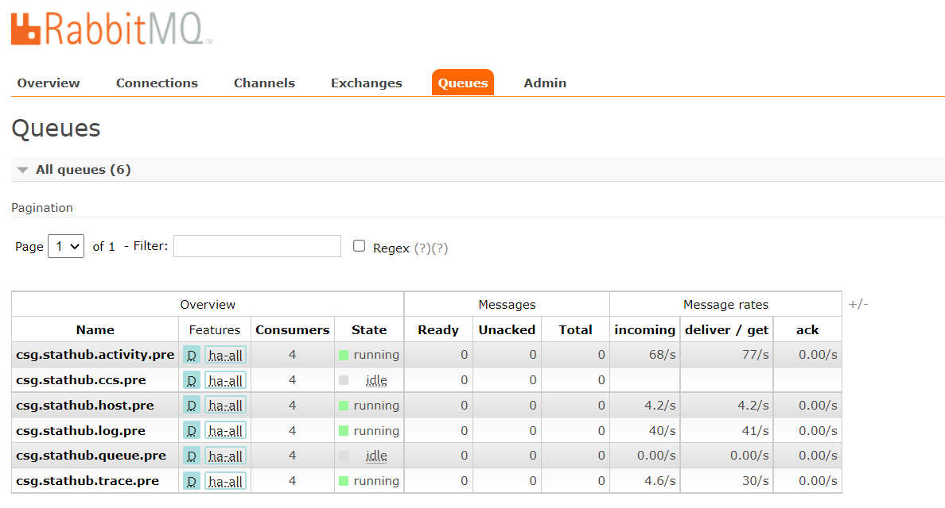
Check State make sure they are running or idle
Check consumers (if you don't have consumers click the +/- button and add them).
In Messages Look for any queues. Should be 0 if not 0 its queuing.

